Market Consultation Solactive Equal Weight Canada REIT Index (SOLCREW)

29 May 2020

Content of the Market Consultation
Solactive AG has decided to conduct a Market Consultation with regard to changing the Index Methodology of the following Index (the ‘Index’):
NAME | RIC | ISIN
Solactive Equal Weight Canada REIT Index | . SOLCREW | DE000SLA1813

Rationale for Market Consultation
Change of the rebalancing logic from 5 day weights adaption to one day implementation of shares. The procedure will be as follows:
- Take the equal weights as of the selection date (2nd Fri), calculate the shares and implement those shares on the rebalancing date (5BD after the selection date)
- The calculated shares will only change due to the relevant corporate actions (splits, rights issue, bonus issues)

Proposed Change to the Index Guideline
The following Methodology change is proposed in the following point of the Index Guideline:
Previous version:
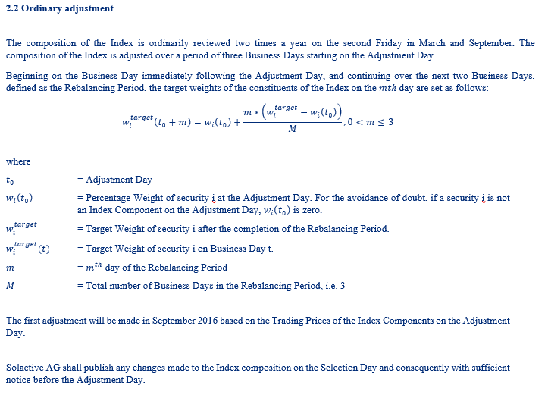
Updated Version:
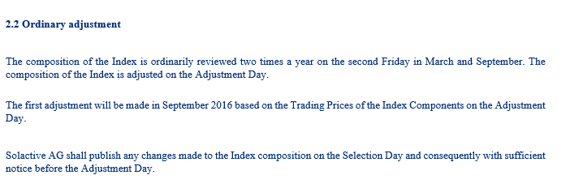

Feedback on the proposed changes
If you would like to share your thoughts with Solactive, please use this consultation form and provide us with your personal details and those of your organization.

Name
Function
Organization
Email
Phone
Confidentiality (Y/N)

Solactive is inviting all stakeholders and interested third parties to evaluate the proposed changes to the Methodology for the SOLACTIVE EQUAL WEIGHT CANADA REIT INDEX (SOLCREW) and welcomes any feedback on how this may affect and/or improve their use of Solactive indices.

Consultation Procedure
Stakeholders and third parties who are interested in participating in this Market Consultation, are invited to respond until 30th June 2020 (cob).
Please send your feedback via email to compliance@solactive.com, specifying “Market Consultation SOLACTIVE EQUAL WEIGHT CANADA REIT INDEX (SOLCREW) “ as the subject of the email, or
via postal mail to: Solactive AG
Platz der Einheit 1
60327 Frankfurt am Main
Germany
Should you have any additional questions regarding the consultative question in particular, please do not hesitate to contact us via above email address.

Contact
Solactive AG
German Index Engineering
Platz der Einheit 1
60327 Frankfurt am Main
Germany
Tel.: +49 (0) 69 719 160 00
Fax: +49 (0) 69 719 160 25
Email: info@solactive.com
Website: www.solactive.com

© Solactive AG

